**Part 1**

**Step 1: Install packages in the current environment**

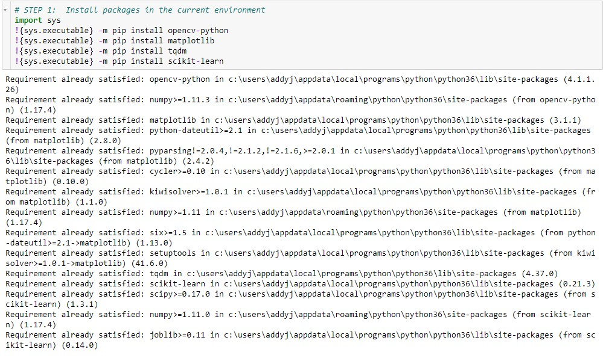

**Step 2: Importing modules**

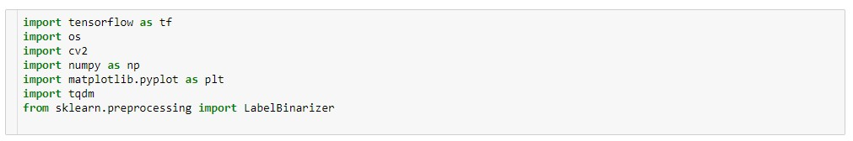

**Step 3: Sequence lengths**

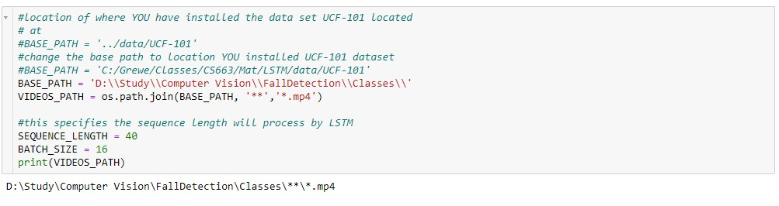

**Step 4 : Printing Dataset**

